Statement of work

Convergys Assist Callback Scheduler

# Revisions

|  |  |  |
| --- | --- | --- |
| **Version** | **Modified By** | **Comments** |
| 1.0 | Cyrus Sembrano | Initial Draft |

Contents

Revisions 2

Overview 2

What is Convergys Assist? 2

New callback scheduler team/client 3

Offline activity tracker to follow 3

About the new version 3

On Desktops 4

Stakeholders 5

Application Specifications 6

Employee Data 6

Agent Schedule Data 6

Callback Data 6

Reporting Specifications 6

Scope of Work 6

# Overview

## What is Convergys Assist?

Convergys Assist is the new version of what formerly was known as Stream Assist. It’s a web application designed to track callback schedules and offline activities. There are 2 sites of this application, one in North America and the other in EMEA. They have same application base, database schema but different records.

The legacy Stream Assist application was built on old components and was prepared only to be handled browsers 2005 to 2008. Furthermore it used to be hosted on a 2003 web server which were now replaced by 2012 servers.

Currently a new team is evaluating internal applications that will best fit their callback scheduling needs. With these facts along with Stream merging with Convergys with the latter as the surviving entity, there is a perfect opportunity to rewrite the web application while maintaining the same database schema and records.

## New callback scheduler team/client

The Dish team in San Salvador is currently evaluating if they are to pilot a callback schedule tracker which they can present to their clients. Their specific requirements will be detailed in this document. The callback feature of Stream assist was built but was only piloted briefly and no other team thought of using the application. It is not very ideal to lead a team anywhere to an untested, unmonitored and unimproved old version of Stream Assist. In this case, starting from ground up will be more ideal.

## Offline activity tracker to follow

The major user of Stream Assist is a team in Poland. As soon as callback scheduling completes its rewrite, development will proceed to covering offline activity tracking. The Poland team has been for years wanting a new version of Stream Assist.

## About the new version

This new version will take advantage of new web technologies. Browsers in recent years became more adherent to newer and more open standards. Websites also adapted to new devices and screen sizes. This will be the vision of Convergys Assist. Responsive to devices and takes advantage of client side scripting. It should be devoid of old third party components with which we don’t have access to source code. At the same time it will have a simpler look and feel making it highly discoverable to the users.

The next few pages will show some screen shots to have a better view of the application.

### On Desktops

#### Login Screen

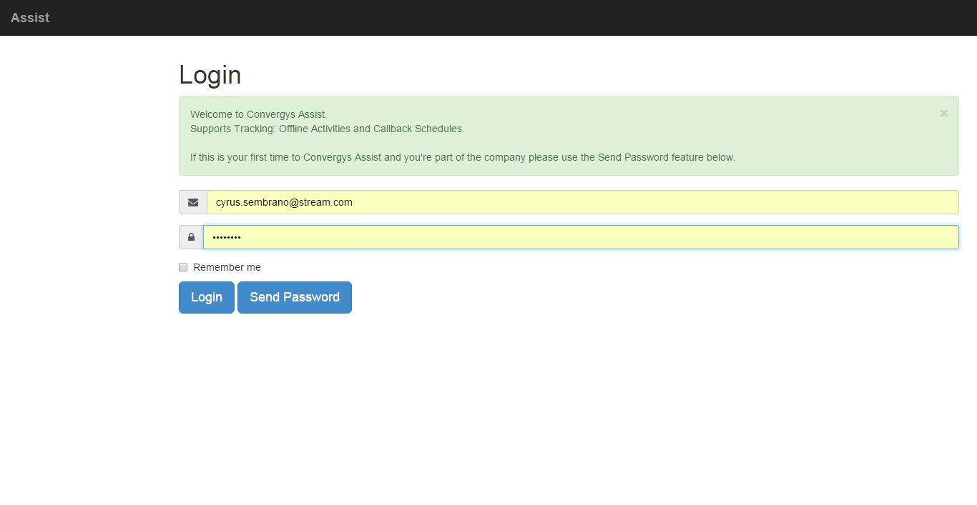

#### Home Screen

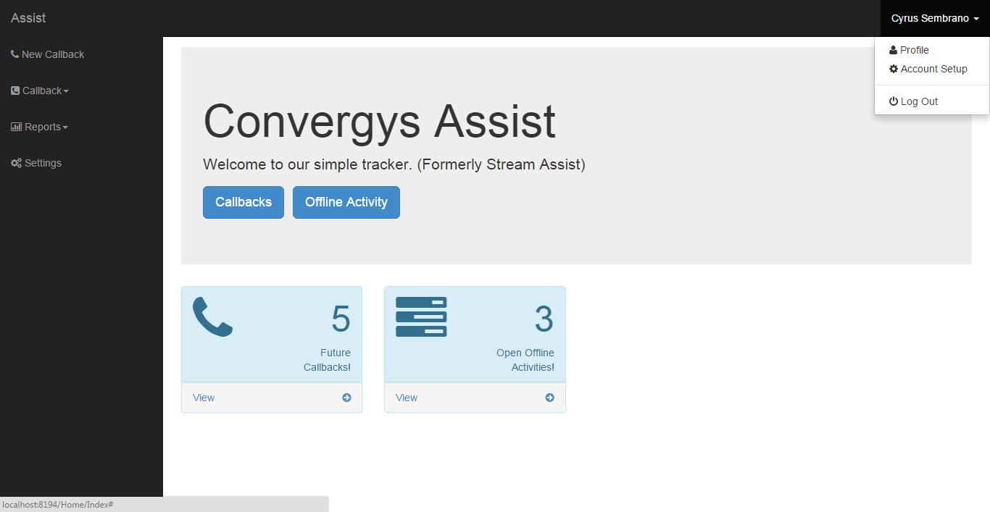

#### Callback Search

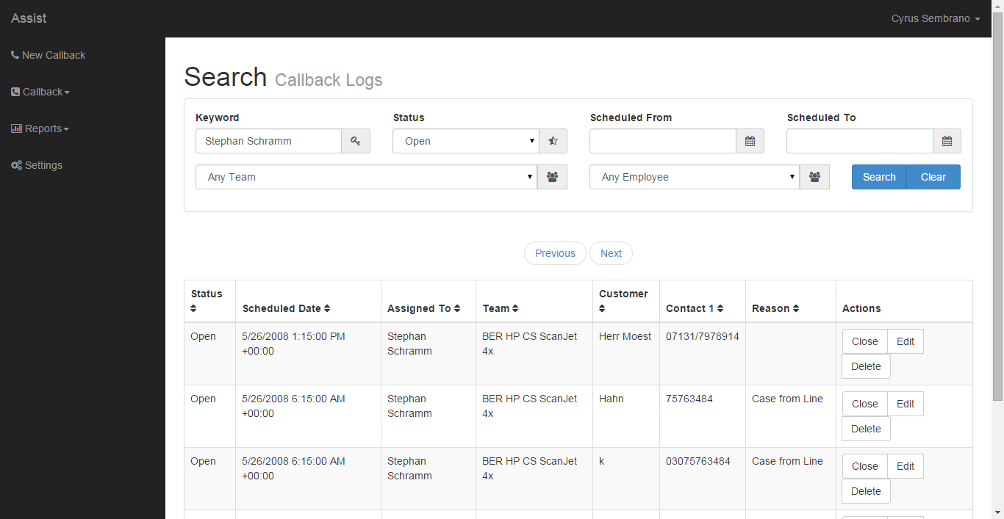

#### Callback Create/View/Edit Screen

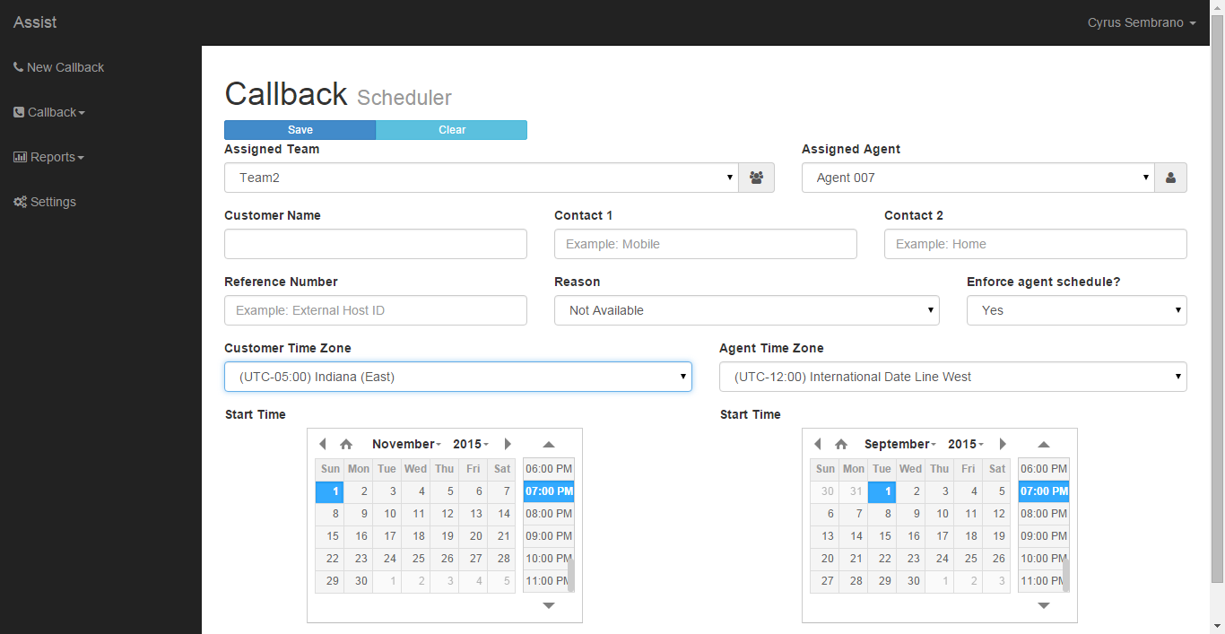

|  |  |
| --- | --- |
| On Mobile |  |
| Login | Home |
|  |  |
| Menu | Search |
|  |  |
| Create Callback 1 | Create Callback 2 |
|  |  |

### On Print

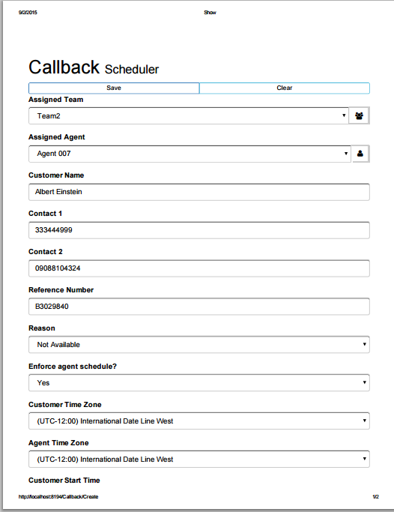

# Stakeholders

|  |  |  |
| --- | --- | --- |
| **Name** | **Role** | **Email** |
| Bethany Meek | DISH San Salvador TM |  |
| Cyrus Sembrano | Application Developer |  |
| Adam Gran | CCA Manager |  |

# Application Specifications

## Employee Data

## Agent Schedule Data

## Callback Data

# Reporting Specifications

# Development Scope

|  |  |  |
| --- | --- | --- |
| **Activity** | **Resource** | **Level of Effort in man hours** |
| Scoping | Application Developer | 2 |
| Web App Infrastructure | Application Developer | 2 |
| ORM and Business Logic Layer Development | Application Developer | 8 |
| Login Screen | Application Developer | 4 |
| Home Screen | Application Developer | 4 |
| Callback Search | Application Developer | 8 |
| Callback Show | Application Developer | 8 |
| Callback Reports | Application Developer | 8 |
| Callback Settings | Application Developer | 8 |
| Profile Settings | Application Developer | 4 |
| Account Settings | Application Developer | 4 |
|  |  |  |

# Client Specific Scope